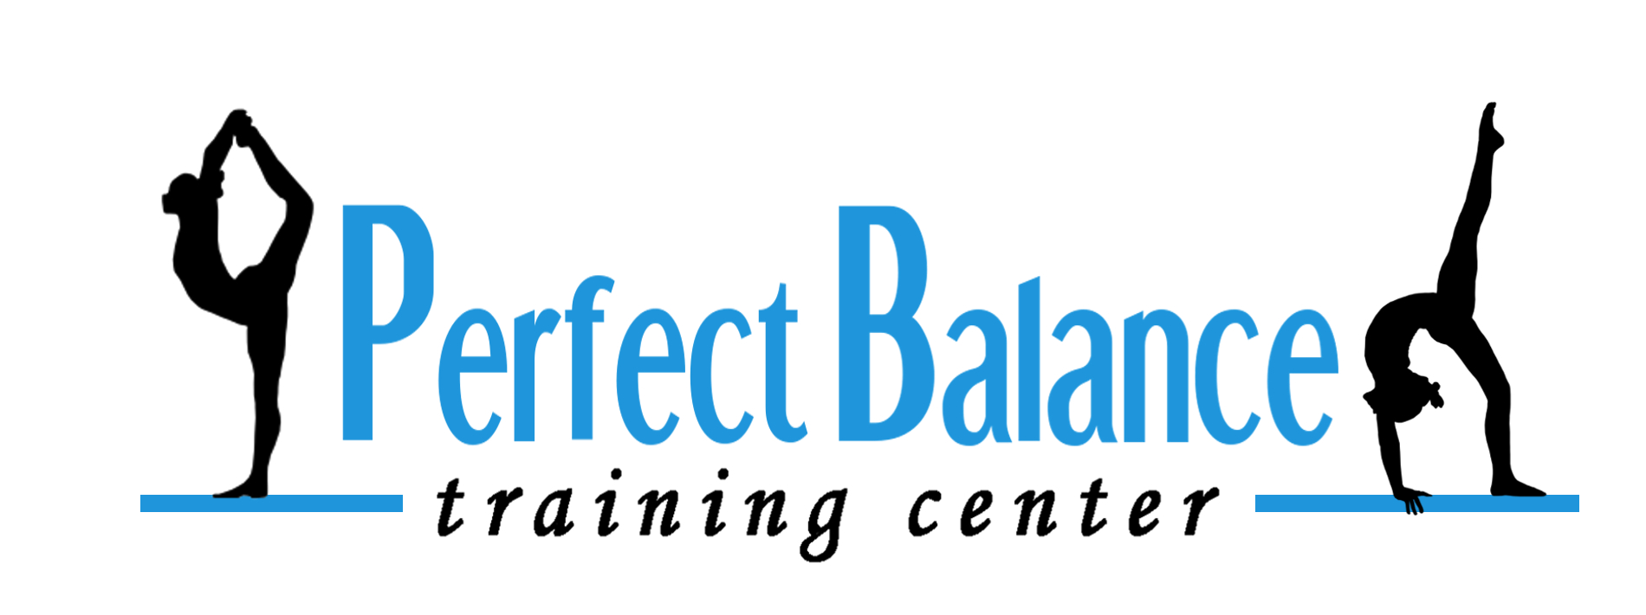
8850 Monroe Road
Charlotte, NC 28212
WAIVER & RELEASE FROM

Participant’s Name: _________________________________________________________ Birthdate _____/_____/__________
Participant’s Name: _________________________________________________________ Birthdate _____/_____/__________
Participant’s Name: _________________________________________________________ Birthdate _____/_____/__________
Parent Name: _____________________________________________________ Phone Number ____________________________
Address:______________________________________________City:__________________________State: ______Zip:_____________
E-Mail Address: __________________________________________________________________________________________________
Emergency Contact: _____________________________________________Phone Number:_____________________________

Perfect Balance Training Center is committed to conducting its activities in the safest manner possible. We hold the safety of the participants in the highest possible regard. Parents must recognize however that there is an inherent risk of injury when choosing to participate in recreational activities. Perfect Balance Training Center continually strives to reduce such risks and insists that all participants follow safety rules and instructions, which have been designed to protect the participant’s safety.

RELEASE OF LIABILITY WAIVER:
WARNING! CATASTROPHIC INJURY, PARALYSIS OR EVEN DEATH CAN RESULT FROM THE IMPROPER CONDUCT OF THE ACTIVITY!
In consideration of Perfect Balance Training Center accepting myself or my child into participation and/or training in gymnastics, which activity I hereby acknowledge involves greater than normal risk of injury, I agree, for myself or as my child’s parent/guardian to assume responsibility for all risks, cost, or losses sustained by me, my child or my child’s family in connection with participation in gymnastics classes, programs, lessons, meets, birthday parties, open gyms, camps, field trips or any other activities connected with Perfect Balance Training Center.
I give my permission to Perfect Balance Training Center staff and/or appropriate medical facility to make whatever emergency (first aid, disaster evacuation, etc.) measures as judged necessary for the care and protection of me or my child while under the supervision of Perfect Balance Training Center.
In case of an emergency, I understand that I or my child will be transported to an appropriate medical facility by the local emergency unit for treatment if the local emergency resources deem it necessary. Transportation will be at my own expense.
It is understood that in some medical situations, the Perfect Balance staff will need to contact the local emergency resource before the parent, physician and/or other acting on behalf of the parent or family can be reached.
Further, I hereby release and agree to hold harmless and to indemnify Perfect Balance Training Center employees, owners and volunteers from any claims, losses or expenses incurred or on the behalf of me, my child or my child’s family.

CONSENT TO PHOTOGRAPH AND MEDIA RELEASE:
I understand that my child’s photograph or video may be taken during the course of class or team instruction, during a special event at Perfect Balance Training Center or at a function sanctioned by Perfect Balance Training Center. I hereby grant permission to Perfect Balance Training Center to use my child’s photograph or likeness in any publicity or promotional publications (e.g. web site, social media, newspaper ads, bulletin boards, newsletters, programs, brochures, public broadcasting releases, etc,) and to allow videoing of my child for broadcast purposes.

I have read and understand this “Release of Liability Waiver” and “Consent to Photograph and Media Release” and I voluntarily affix my name in agreement.

Participant’s Name: _________________________________________________________Date: _____/_____/____________
(If Participant is 18 Years or Older)

Parent/Guardian Signature _________________________________________________Date: _____/_____/____________

